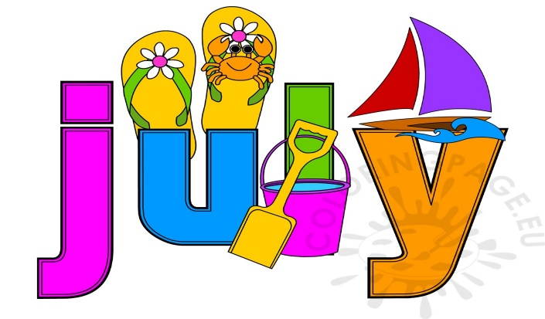 2022
MONDAY | TUESDAY | WEDNESDAY | THURSDAY | FRIDAY
VISIT US ON OUR  WEBSITE:  www.brooklettsplace.org  VISIT US ON FACEBOOK AT  BROOKLETTS PLACE – TALBOT SENIOR CENTER |  |  |  | 1  9:00 Coffee Hour  10:00 Mahjong  12:00 Lunch  12:00 Guitar & Ukulele Lessons  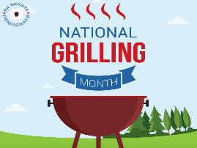
4  CLOSED | 5  9:00 Coffee Hour  10:30 Pinochle  12:00 Lunch  12:30 Yarn & Needle Group  What do you call a funny mountain?  Hill-arious | 6  9:00 Coffee Hour  9:00 Beginning Oil Painting  10:00 Wii Bowling  11:30 Duplicate Bridge  12:00 Lunch  On This Day in 2002: Serena Williams beats older sister Venus for her first Wimbledon singles title. | 7  9:00 Coffee Hour  12:00 Lunch & Learn  w/Humana | 8  9:00 Coffee Hour  10:00 Mahjong  12:00 Lunch  12:00 Guitar & Ukulele Lessons  12:00 Poetry at Noon  What do lawyers wear to court?  Lawsuits!
11  9:00 Coffee Hour  10:00 Advance Beginners  Watercolor  12:00 Mahjong  12:00 Lunch & Learn  w/MELANIE  What is the best day to go to the beach?  Sunday, of course! | 12  8:00 Gentle Yoga  9:00 Coffee Hour  10:00 Crafting with Tonia  10:30 Pinochle  12:00 Lunch  12:30 Yarn & Needle Group  On This Day in 1976:  1st Family Feud game show debuts on ABC hosted by Richard Dawson | 13  9:00 Coffee Hour  9:00 Beginning Oil Painting  10:00 Wii Bowling  11:30 Duplicate Bridge  12:00 Lunch  “Parenting is an impossible job at any age”  Happy Birthday Harrison Ford 07.13.1942  . | 14  9:00 Coffee Hour  10:00 Blood Pressure  Screening  12:00 Lunch w/Gene Edwards  Review | 15  9:00 Coffee Hour  9:30 Dance Fitness  10:00 Mahjong  11:30 Toastmaster’s  12:00 Lunch  12:00 Guitar & Ukulele Lessons
18  9:00 Coffee Hour  10:00 Advance Beginners  Watercolor  12:00 Mahjong  12:00 Lunch | 19  8:00 Gentle Yoga  9:00 Coffee Hour  10:30 Pinochle  12:00 Lunch  12:30 Yarn & Needle Group  On This Day in 1941:  Tom and Jerry first appear under their own names in cartoon The Midnight Snack by William Hanna and Joseph Barbera. | 20  9:00 Coffee Hour  9:00 Beginning Oil Painting  10:00 Wii Bowling  11:30 Duplicate Bridge  12:00 Lunch | 21  9:00 Coffee Hour  12:00 Lunch & Learn  w/Humana  On This Day in 1943:  Stormy Weather, starring Bill Robinson, Lena Horne and Fats Waller singing Ain't Misbehavin' premieres. | 22  9:00 Coffee Hour  9:30 Dance Fitness  10:00 Mahjong  12:00 Lunch  12:00 Guitar & Ukulele Lessons  Why do fish live in salt water?  Because pepper makes them sneeze!
25  9:00 Coffee Hour  10:00 Advance Beginners  Watercolor  12:00 Mahjong  12:00 Lunch & Learn  Why is England the wettest country?  Because the queen has reigned there for years! | 26  8:00 Gentle Yoga  9:00 Coffee Hour  10:30 Pinochle  10:30 Positive Music w/DJ  Randy P  12:00 Lunch  12:30 Yarn & Needle Group | 27  9:00 Coffee Hour  9:00 Beginning Oil Painting  10:00 Wii Bowling  11:30 Duplicate Bridge  12:00 Lunch  On This Day in 1866:  The first permanent transatlantic telegraph cable was successfully completed, stretching from Valentia Island, Ireland, to Heart's Content, Newfoundland (1,686 miles long). | 28  9:00 Coffee Hour  10:00 Elder Law Clinic  10:00 Armchair Travels with  Tonia  12:00 Lunch  NATIONAL  CHILLI DOG DAY | 29  9:00 Coffee Hour  9:30 Dance Fitness  10:00 Mahjong  12:00 Lunch  12:00 Guitar & Ukulele Lessons  Why did the robber take a bath?  Because he wanted to make a clean getaway!  😊

BROOKLETTS PLACE – TALBOT COUNTY SENIOR CENTER –JULY 2022
400 BROOKLETTS AVENUE * EASTON, MD 410-822-2869

OUTINGS & EVENTS:
Thurs., July 7 - (12:15 p.m. – 1:00 p.m.) Lunch & Learn w/Humana. Please join Clifton L. Gadsden, Sr./Sales Representative for “Power of Positivity” – Life can be challenging; many situations can arise that make it easy to feel negative about your circumstances. In spite of this, there are actions you can take to help you view your life in a positive light. A two-week advance sign-up is required for lunch or you may bring your own.
Mon., July 11 - (12:15 p.m. – 1:00 p.m.) Lunch & Learn w/Melanie. University of Maryland Shore Regional Health presents: Medication 101 with Melanie. The #1 way to stay healthy is taking medications as the doctor ordered. Join Melanie Chapple, Pharm-D, transitions pharmacist at the Easton, Dorchester & Chestertown hospitals of Shore Regional Health as she gives tips on medication safety, medication organization and cost savings. A two-week advance sign-up is required for lunch or you may bring your own.
Thursday, July 14 – (12:00 p.m. – 1:00 p.m.) Lunch/Music with Gene Edwards Review digital keyboard and vocal music, featuring a full array of amazing hits. A two-week advance sign-up is required for lunch or you may bring your own.
Thurs., July 21 - (12:15 p.m. – 1:00 p.m.) Lunch & Learn w/Humana. Please join Clifton L. Gadsden, Sr./Sales Representative for “Using Technology” - Learning how to use technology can be frustrating, but it can be a great tool for helping you stay connected to friends and family who are far away. A two-week advance sign-up is required by June 7th for lunch or you may bring your own.

UPCOMING TRIPS: Please visit our website www.brooklettsplace.org

ALASKA CRUISE, LAND & RAIL W/PRINCESS CRUISES® ON THE MAJESTIC PRINCESS®
11 DAYS / 10 NIGHTS ~ SEPTEMBER 6 – 16, 2023
Click here: Talbot County Senior Center Presents Alaska Cruise, Land, & Rail on the Majestic Princess® - September 6 - 16, 2023

FREE PROGRAMS: Advance sign-up requested for most programs – PLEASE NOTE – IF YOU SIGN UP FOR ANY OF THE FREE PROGRAMS THAT HAVE SPACE LIMITATIONS AND ARE UNABLE TO ATTEND, PLEASE BE COURTEOUS AND CALL TO LET US KNOW BECAUSE SOMEONE ELSE CAN BE PUT IN YOUR SLOT. ADDITIONALLY IN SOME CASES A FEE MAY APPLY FOR NO SHOWS!!

- Tues., July 14- (10:00 a.m. – 11:00 a.m.) Free “Summer Time – T-Shirt” Craft – Bring Your Own T-Shirt to design and Join us for Crafting with Tonia. Limited to 10 participants – Advance sign-up is required.
- Tues., July 26 – (10:30 a.m. – 11:30 a.m.) “Positive Music w/DJ Randy P”. Reduce your weekly stress by enjoying a fun, safe, and positive musical experience in a motivation environment
- Thurs., July 28 (10:00 a.m. – 11:00 a.m.) Armchair Travel w/Tonia. Let’s travel to Mexico w/Tonia. Mexico! The land of tacos, Aztecs, sombreros and tequila! This fascinating country encompasses epic landscapes, from shimmering beaches to lush jungles, snow-capped mountains and cactus-strewn deserts.
- Thurs., July 28 - (10:00 a.m. – 1:00 p.m.) Elder Law Clinic Attorneys will be present (by appointment only) to discuss legal issues pertaining to seniors to include: Elder Abuse, Adult Guardianship; homeowner and consumer related issues and much, much, more. Contact Mid-Shore Pro-Bono at 410-690-8128 for an appointment or additional information.

SELF-PAY CLASSES: SPACE AVAILABLE IN ALL CLASSES.
- Advance Beginners Watercolor - Every Monday (10:00 a.m. – 12:00 p.m.) $50.00 per 4 week session. New students are welcome, contact Diana Evans, Instructor 443-239-0657
- Beginning Oil Painting – Every Wednesday (9:00 a.m. – 12:00 p.m.) $5.00 per hour. NO CHARGE for SUPPLIES for first three sessions. New students are welcome. Contact Jane Bollman, Instructor at 410-770-8611 or bollman@goeaston.net for additional information or to register
- Intermediate Watercolor - Every Thursday (10:00 a.m. – 12:00 p.m.) $50.00 per 4 week session. New students are welcome, Diana Evans, Instructor 443-239-0657
- Guitar and Ukulele Lessons with Emma Bailey of Mike Elzey Guitar Every Friday at 12 noon $5.00 per session

OTHER PROGRAMS:
- Yarn & Needle Group – Every Tuesday 12:30 p.m. If you knit, crochet, needlepoint, felt or weave, this is the Gathering for you. Practice your craft and bring your skills to others for a hour or two – whatever fits your schedule. Open to members at no cost. No registration necessary, just drop in. Call 410-820-9563 for more information.
- Video (Wii) Bowling - Every Wednesday 10:00 a.m. in the TV Room. Come Join the Team New Members Are Welcome!
- Blood Pressure Screening – 1st Thursday of each month at 10:00 a.m. (2nd Thursday in July Only)
- Elder Law Clinic – Every 4th Thursday 10:00 a.m. – 1:00 p.m. BY APPOINTMENT ONLY Contact Mid-Shore Pro-Bono at 410-690-8128
- Poetry at Noon – Every 1st & 3rd Friday (July - 2nd Friday Only)

