2022
MONDAY | TUESDAY | WEDNESDAY | THURSDAY | FRIDAY
1  9:00 Coffee Hour  10:00 Advance Beginners  Watercolor  12:00 Mahjong  12:00 Lunch  What do you call a fake noodle?  An impasta! | 2  9:00 Coffee Hour  10:30 Pinochle  12:00 Lunch  12:30 Yarn & Needle Group | 3  9:00 Coffee Hour  9:00 Beginning Oil Painting  10:00 Wii Bowling  11:30 Duplicate Bridge  12:00 Lunch  What does a lazy dog chase?  Parked cars | 4  9:00 Coffee Hour  10:00 Blood Pressure  Screening  12:00 Lunch | 5  9:00 Coffee Hour  9:30 Dance Fitness  10:00 Mahjong  11:30 Toastmaster’s  12:00 Lunch  12:00 Guitar & Ukulele Lessons  On This Day In 1957  American Bandstand premieres on network TV (ABC)
8  9:00 Coffee Hour  10:00 Advance Beginners  Watercolor  12:00 Mahjong  12:00 Lunch  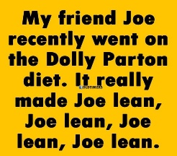 | 9  9:00 Coffee Hour  10:00 Crafting with Tonia  10:30 Pinochle  12:00 Lunch  12:30 Yarn & Needle Group | 10  8:30 Commission on Aging  9:00 Coffee Hour  9:00 Beginning Oil Painting  10:00 Wii Bowling  11:30 Duplicate Bridge  12:00 Lunch  Where do bulls exchange their messages?  On a bull-etin board. | 11  9:00 Coffee Hour  12:00 Lunch w/Gene Edwards  Review  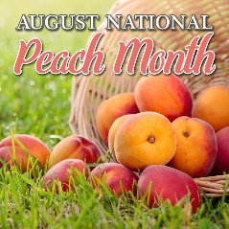 | 12  9:00 Coffee Hour  9:30 Dance Fitness  10:00 Mahjong  12:00 Lunch  12:00 Guitar & Ukulele Lessons  12:00 Poetry at Noon  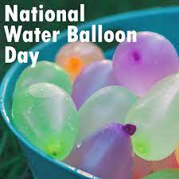
15  9:00 Coffee Hour  10:00 Advance Beginners  Watercolor  12:00 Mahjong  12:00 Lunch | 16  9:00 Coffee Hour  10:30 Pinochle  12:00 Lunch  12:30 Yarn & Needle Group | 17  9:00 Coffee Hour  9:00 Beginning Oil Painting  10:00 Wii Bowling  11:30 Duplicate Bridge  12:00 Lunch | 18  9:00 Coffee Hour  12:00 Lunch  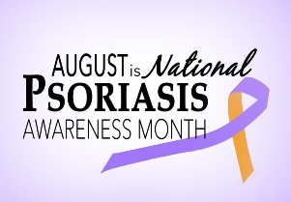 | 19  9:00 Coffee Hour  9:30 Dance Fitness  10:00 Mahjong  11:30 Toastmaster’s  12:00 Lunch  12:00 Guitar & Ukulele Lessons  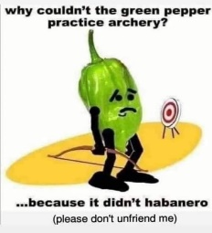
22  9:00 Coffee Hour  10:00 Advance Beginners  Watercolor  12:00 Mahjong  12:00 Lunch  What does summer say to spring every year?  Please help me, I'm going to fall | 23  9:00 Coffee Hour  10:30 Pinochle  12:00 Lunch  12:30 Yarn & Needle Group | 24  9:00 Coffee Hour  9:00 Beginning Oil Painting  10:00 Wii Bowling  11:30 Duplicate Bridge  12:00 Lunch  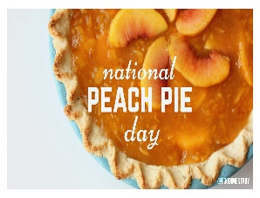 | 25  9:00 Coffee Hour  10:00 Elder Law Clinic  10:00 Armchair Travels with  Tonia  12:00 Lunch  On this Day in 1968  Arthur Ashe becomes the 1st African American to win the US singles championship. | 26  9:00 Coffee Hour  9:30 Dance Fitness  10:00 Mahjong  11:00 Chubb’s Grilling on the  Move Fundraiser  12:00 Lunch  12:00 Guitar & Ukulele Lessons  When does Friday come before Thursday?  In the dictionary!
29  9:00 Coffee Hour  10:00 Advance Beginners  Watercolor  12:00 Mahjong  12:00 Lunch | 30  9:00 Coffee Hour  10:30 Pinochle  10:30 Positive Music w/DJ  Randy P  12:00 Lunch  12:30 Yarn & Needle Group  “I always knew I was going to be rich. I don't think I ever doubted it for a minute.”  Happy Birthday  Warren Buffet  August 30, 1930 | 31  9:00 Coffee Hour  9:00 Beginning Oil Painting  10:00 Wii Bowling  11:30 Duplicate Bridge  12:00 Lunch | VISIT US ON OUR  WEBSITE:  www.brooklettsplace.org  VISIT US ON FACEBOOK AT  BROOKLETTS PLACE – TALBOT SENIOR CENTER

BROOKLETTS PLACE – TALBOT COUNTY SENIOR CENTER –AUGUST 2022
400 BROOKLETTS AVENUE * EASTON, MD 410-822-2869

OUTINGS & EVENTS:
Thursday, August 11 – (12:00 p.m. – 1:00 p.m.) Lunch/Music with Gene Edwards Review digital keyboard and vocal music, featuring a full array of amazing hits. A two-week advance sign-up is required for lunch or you may bring your own.
Fri., August 26 – (11:00 a.m. – 2:00 p.m.) Brookletts Place Fundraiser with Chubb’s Grilling On the Move” ½ Chicken or Pulled Pork Platters $12.00 include coleslaw, chips and a drink, or pulled pork sandwich $8.00. Advance orders may be placed by calling 410-822-2869 or email at abrown@uppershoreaging.org. Deadline will be August 19th. Limited availability day of event, advance orders are recommended. Also – Medication Take Back Barrell will be available so please bring your expired/unused medications for proper disposal. Sponsored by Talbot County Sheriff’s Office.

UPCOMING TRIPS: Please visit our website www.brooklettsplace.org

ALASKA CRUISE, LAND & RAIL W/PRINCESS CRUISES® ON THE MAJESTIC PRINCESS®
11 DAYS / 10 NIGHTS ~ SEPTEMBER 6 – 16, 2023
$100.00 PER PERSON DEPOSIT EXTENDED UNTIL AUGUST 31, 2022!!!
Right Click here & click on “Open Hyperlink”: Talbot County Senior Center Presents Alaska Cruise, Land & Rail on the Majestic Princess® ~ September 6, 2023

FREE PROGRAMS: Advance sign-up requested for most programs – PLEASE NOTE – IF YOU SIGN UP FOR ANY OF THE FREE PROGRAMS THAT HAVE SPACE LIMITATIONS AND ARE UNABLE TO ATTEND, PLEASE BE COURTEOUS AND CALL TO LET US KNOW BECAUSE SOMEONE ELSE CAN BE PUT IN YOUR SLOT. ADDITIONALLY IN SOME CASES A FEE MAY APPLY FOR NO SHOWS!!

- Tues., August 9- (10:00 a.m. – 11:00 a.m.) Free “Summer Time – Wind Chimes” Craft – Join us for Crafting with Tonia. Limited to 10 participants – Advance sign-up is required.
- Thurs., August 25 (10:00 a.m. – 11:00 a.m.) Armchair Travel w/Tonia. Let’s travel to Spain w/Tonia. Spain! The land of siestas, fiestas, and flamenco. A vibrant mix of modern and traditional and a unique appreciation for the good life!
- Thurs., August 25 - (10:00 a.m. – 1:00 p.m.) Elder Law Clinic Attorneys will be present (by appointment only) to discuss legal issues pertaining to seniors to include: Elder Abuse, Adult Guardianship; homeowner and consumer related issues and much, much, more. Contact Mid-Shore Pro-Bono at 410-690-8128 for an appointment or additional information.
- Tues., August 30 – (10:30 a.m. – 11:30 a.m.) “Positive Music w/DJ Randy P”. Reduce your weekly stress by enjoying a fun, safe, and positive musical experience in a motivation environment

SELF-PAY CLASSES: SPACE AVAILABLE IN ALL CLASSES.
- Advance Beginners Watercolor - Every Monday (10:00 a.m. – 12:00 p.m.) $50.00 per 4 week session. New students are welcome, contact Diana Evans, Instructor 443-239-0657
- Beginning Oil Painting – Every Wednesday (9:00 a.m. – 12:00 p.m.) $5.00 per hour. NO CHARGE for SUPPLIES for first three sessions. New students are welcome. Contact Jane Bollman, Instructor at 410-770-8611 or bollman@goeaston.net for additional information or to register
- Guitar and Ukulele Lessons with Emma Bailey of Mike Elzey Guitar Every Friday at 12 noon $5.00 per session

OTHER PROGRAMS:
- Yarn & Needle Group – Every Tuesday 12:30 p.m. If you knit, crochet, needlepoint, felt or weave, this is the Gathering for you. Practice your craft and bring your skills to others for a hour or two – whatever fits your schedule. Open to members at no cost. No registration necessary, just drop in. Call 410-820-9563 for more information.
- Video (Wii) Bowling - Every Wednesday 10:00 a.m. in the TV Room. Come Join the Team. New Members Are Welcome!
- Blood Pressure Screening – 1st Thursday of each month at 10:00 a.m.
- Elder Law Clinic – Every 4th Thursday 10:00 a.m. – 1:00 p.m. BY APPOINTMENT ONLY Contact Mid-Shore Pro-Bono at 410-690-8128
- Poetry at Noon – Every 1st & 3rd Friday

UPCOMING EVENTS:
Sign Up NOW!! For a Computer Basics Class beginning Sept 6th 1:15 p.m. – 2:00 p.m. at Brookletts Place.
SEPT 18-24, 2022 – FALLS PREVENTION WEEK
SEPT 19 – 10:00 a.m. KICK OFF FOR THE STRONGERMEMORY PROGRAM - The StrongerMemory Program is a 12 week/1 hour per week program, an innovative brain health program for older adults. Advance sign-up is required.

